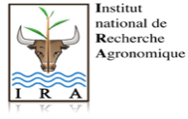

SECOND ANNOUNCEMENT

7th International Conference of the Pan African Fish and Fisheries Association (PAFFA)
African Fish and Fisheries:
Diversity, Conservation & Sustainable Management

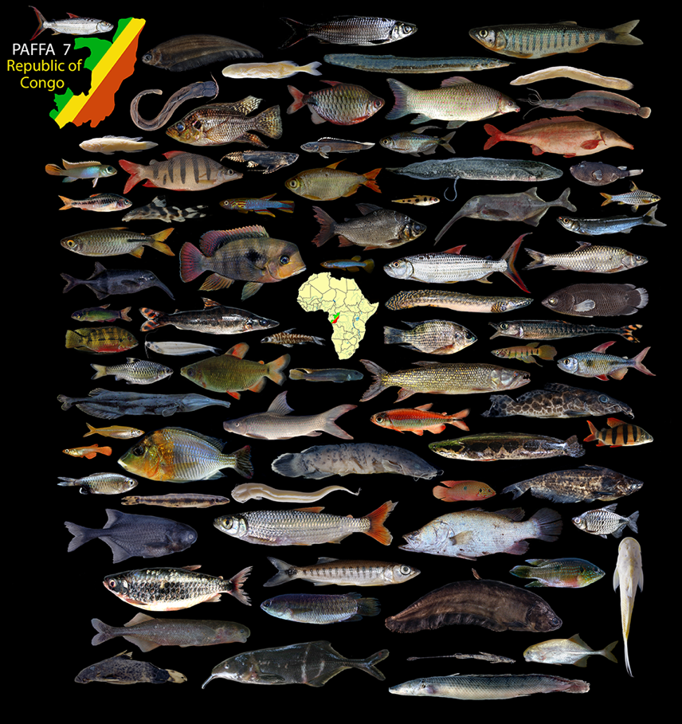

University of Marien Ngouabi, Brazzaville (Republic of the Congo)
18 – 22 (23) September 2023.

Organized by the Department of Oceanography and Environment of the National Institute of Research in Exact and Natural Sciences (IRSEN), the National School of Agronomy and Forestry of the University of Marien Ngouabi and the Laboratory of Research in Biology and Animal Ecology (LARBEA) of the ’Ecole Normale Supérieure’ (ENS) of the University of Marien Ngouabi.

With the financial support of the:

- Royal Museum for Central Africa (Tervuren, Belgium)
- American Museum of Natural History (New York, USA)
- JRS Biodiversity Foundation (Virginia, USA) through the Biodiversity Research Institute of Tulane University (USA)
- Museu de Zoologia – Universidade de São Paulo (Brazil)

Other interested sponsors are welcome.

INTRODUCTION

The fresh- and brackish water fish fauna of Africa is highly diverse and comprises over 3700 species belonging to some 520 genera and about 90 families. These fishes inhabit a wide variety of habitats ranging from small temporary streams to large and permanently flowing rivers, as well as from shallow and swampy water bodies to large deep lakes, in dry and wet climatic zones.
In many African countries, fishes are a major source of protein and income generation. While in many regions capture fisheries are fully or over-exploited, the development of aquaculture in Africa continues to lag its predicted potential. Despite its economic and social importance, the African fish fauna is exposed to many threats, most of which are of anthropogenic origin. The major causes of the loss of fish diversity are habitat alteration, the introduction of alien species, overexploitation of fisheries resources, and pollution.
Much research has been, or is being, conducted on the fish and fisheries of the African continent. To access and share this growing body of scientific knowledge, it was recognized that an international gathering bringing together scientists from around the globe was required. The first of such meetings took place in 1993 in Dakar, Senegal; the second in Grahamstown, South Africa in 1998; the third in Cotonou, Benin in 2003, the fourth in Addis Ababa, Ethiopia in 2008, the fifth in Bujumbura, Burundi in 2013, the sixth in Mangochi, Malawi in 2018, and the seventh is now due to take place on 18-22 September 2023 in Brazzaville (Republic of the Congo).
This meeting provides an opportunity for scientists from throughout Africa and around the World to come together, to get to know one another, exchange information and ideas, and to initiate collaborative studies. The conference is by far the largest one for scientists studying African fishes and many renowned scientists, young researchers, and other stakeholders are expected to attend this important meeting.
We ask you to assist us in disseminating this information to all relevant individuals and institutions. If you have any questions or queries, please don’t hesitate to contact the organizing committee at paffa2023@gmail.com.
A website is currently under development for PAFFA 7, and once accessible the url for the site will be made available and regularly updated with information.

THEMES OF THE CONFERENCE
1. Fish systematics, biodiversity research and data management
- Taxonomy, morphological and molecular systematics, and phylogenomics.
- Evolution and speciation, adaptive radiation, bio- and phylogeography.
- Biotic surveys and inventories, including eDNA studies.
- Databases and bioinformatics, strategies for information sharing.

2. Biology, ecology, and behaviour
- Ecology, life history strategies, and migratory biology.
- Parasites and diseases.
- Behaviour, morphology, and physiology.

3. Aquatic resource conservation and management
- Human impact on fish diversity and exploitation.
- Freshwater biodiversity as indicators of health.
- Conservation strategies and sustainable management of aquatic systems.

4. Fish and food security
- Capture fisheries, aquaculture, and ornamental fish trade.
- Socioeconomics of fish diversity in human culture.

International Organizing Committee
V. Mamonekene (R. Congo), A. Ibala Zamba (R. Congo), E. Kaunda (Malawi), G. Banyankibona (Burundi), A. Getahun (Ethiopia), Ph. A. Laleye (Benin), H. Bart (USA), M.L.J. Stiassny (USA), M. De Pinna (Brazil), J. Snoeks (Belgium).

Local Organizing Committee
Prof. V. Mamonekene (Department of Oceanography and Environment, IRSEN/ENSAF, UMNG), Prof. A. Ibala Zamba Department of Oceanography and Environment, IRSEN/National Institute of Agricultural Research/ENSAF, UMNG),
Prof. I. Mady Goma Dirat (Laboratory for Research in Biology and Animal Ecology, ENS), Prof. J. Goma-Tchimbakala (National Institute of Research in Exact and Natural Sciences (IRSEN), Dr. D.B. Olabi Obath (Laboratory for Research in Biology and Animal Ecology, ENS), Prof. E.A. Issali (National Institute of Agricultural Research), Dr. M. Nkoua Gavouka (National Institute of Research in Exact and Natural Sciences (IRSEN).

Contact: Email paffa2023@gmail.com

Official Languages: English and French

Website: Coming soon.

VISAS: Delegates are responsible for their own visa arrangements. We recommend that as soon as possible you check with your local travel agent and/or Embassy of the Republic of Congo in your home country to find out if a visa is required. For attendees needing a visa, the organizing committee is trying to obtain a downloadable general letter of invitation for all registered participants to include in their visa request packages. As visa requirements for PAFFA 7 attendance are resolved more details will be provided on the website, and in the final announcement.

Health: Proof of a Yellow Fever vaccination is required for entry, and malarial prophylaxis is strongly recommended for visitors coming from outside malarial endemic areas. Currently no proof of Covid vaccination is required for entry. Any changes in requirements will be posted on the PAFFA 7 website.

Climate and Clothing: September is among the hottest months in the Brazzaville region with temperatures ranging between 20ºC (68ºF) and 35ºC (95ºF), with an average of 25ºC (77ºF). September is at the end of the dry season, but occasional showers are possible.

Collecting Advisory: Please be aware that any letter of invitation sent from the conference organizers only covers participation in PAFFA 7. Exportation of biological materials, without official permission and necessary documentation/permits is not allowed. For those wanting to make and export fish collections please contact the Ministry of Forest Economy and the Ministry of Higher Education and Scientific Research.

Third and Final Announcement: All who have responded to this second announcement will receive the Third and final announcement by 31 July 2023.

REGISTRATION FEES:

Full Students
M.Sc./PhD

Early registration Within Africa $170 or €170 $100 or €100
(Received by June 15th) Outside Africa $300 or €300 $180 or €180

Late registration Within Africa $220 or €220 $130 or €130
Outside Africa $350 or €350 $220 or €220

Please Note: Registration fees are to be paid by direct bank transfer, international money transfer, or by cheque in US dollars or Euros to the following account:
Name of Bank: Crédit du Congo
Bank address: BP 2400, Brazzaville, Republic of Congo
Account name: Association Panafricaine des Poissons et Pêches
Account number: 30011-00020-90000298690-55
Swift Code/BIC: BCMACGCG
IBAN: CG3930011000209000029869055
Please be sure to add your name, and “Registration fee payment for PAFFA 7 Conference, Brazzaville”.
Note: Cancellations after 15 July 2023 will not be reimbursed. Cancellation before this date will be subject to a 25% penalty.
Registration fees cover the following:
- Book of abstracts.
- Conference kit.
- Official reception (Monday).
- Refreshments (Monday to Friday).
- Sandwich lunches (Monday to Friday).
- Mid-conference excursion (Wednesday).
- Conference banquet (Wednesday evening).
- Farewell social and announcement of student prizes (Friday evening).
- Bioinformatics Workshop (Saturday).

Please indicate on the registration form if you have any dietary restrictions; the conference organizers will do their best to accommodate them.
Student Prizes: There will be student prizes for the best student oral and poster presentations.
Accommodations: Brazzaville has many hotels offering a range of facilities and prices. Below we provide the prices and contact details for selected hotels in Brazzaville, focused on those in proximity to the conference venue (see list below). Participants are responsible for their own hotel bookings. As available, additional hotel options will be added to the website.
Currency: Local currency is the Central African (CFA) franc, which is tied to the Euro. Most restaurants and hotels do not accept credit cards but will accept Euros. US$ are also accepted but at a fluctuating exchange rate.
Traveling around town: Brazzaville has a safe, low-cost, and convenient system of official taxis. Cost to and from the airport to hotels in the vicinity of the conference venue are about 3000 CFA, and within the city, for most short distances, about 1000 CFA.

Instructions for submission of abstracts
Abstract deadline: Abstracts must be submitted before 15 June 2023. Please specify whether your abstract is for an oral presentation or a poster.
Language of abstract: Your abstract must be written in either English or French and indicate that this is your “Official abstract”. Provide a translation in French or English (to be marked as “Abstract translated”). This is required as a service to the mixed language PAFFA audience and will make your study accessible a much larger public. We stress that translations need not be perfect and web-based translation sites such as Google Translate, or others are completely acceptable – the goal is to convey the science not the grammar.
Abstract title: Title must be concise and give a clear indication of the content of the presentation.
Author (s): must be indicated with their initial/s followed by family name/s. Please underline the name of the presenting author.
Name of Institution/s: Please be concise; institution name should be followed by town and country of the lead author.
Text: Text must be informative and concise, and should contain:
- A summary of the study’s specific aims
- A summary of methods
- A summary of results
- A summary of conclusions

Format: Font size of 12 points for the whole document; the font should be ‘Times New Roman’. All text must be single spaced, with 2.5 cm left and right margins. Abstract must not exceed 300 words (in the primary language).
Submission: Abstracts and translated abstracts must be written using Microsoft Word and be sent as an attachment by e-mail to: paffa2023@gmail.com.
Timing of presentations: Keynote addresses will be 30 minutes (20 minutes presentation and 10 minutes for discussion). All other presentations are limited to 15 minutes (10 minutes presentation and 5 minutes for discussion). As concurrent sessions will be taking place, all presenters will be held to these strict time limits.
Posters: Poster boards will be available. Presenters need to install their posters on Sunday 17 September in the afternoon. Posters will remain on display until the end of the conference. The maximum dimensions for posters should be 1.20 m (height) x 0.9 m (width).
Technical workshop: With funding from the JRS Biodiversity Foundation (Virginia, USA) through the Biodiversity Research Institute of Tulane University (USA) a training workshop on Biodiversity Informatics: methodologies and user training, will be held on Saturday July 23rd. The workshop will be open to all conference attendees at no additional cost. Full details of the workshop will be provided on the PAFFA 7 website and in the third announcement.

Social Program
Sunday, 17 September Welcome cocktail.
Monday, 18 September Official reception and social.
Tuesday, 19 September Free Evening.
Wednesday, 20 September Mid-day excursion and early evening banquet.
Thursday, 21 September Free Evening.
Friday, 22 September End of Conference social, and student awards.
Saturday 23 September JRS sponsored workshop.

Mid-conference excursion (costs included in registration fees): A mid-conference excursion on Wednesday, 20 Sept. 2023 along the Congo River, near the first rapids at the outlet of the Pool Malebo into the lower Congo River, followed by a conference banquet at a restaurant overlooking the rapids.
Pre- or post-conference excursion: There is much to see in the Republic of Congo and pre-or post-conference excursions/in-country flights/lodges may be organized by contacting local travel agencies. A list of recommended agencies will be added to the PAFFA7 website and sent in the final announcement.

REGISTRATION FORM
A completed registration form and abstract should be emailed to paffa2023@gmail.com. The deadline for inclusion is 15 June 2023, late submissions may not be able to be incorporated into the program or abstract book.
Please return the form below if you plan to contribute a poster, oral presentation and/or to receive the third announcement.

Title: Prof. □ Dr. □ Mr. □ Ms. □
Surname: ________________________________________________________
Given name: _____________________________________________________
Institution: ______________________________________________________
Address: ___________________________________________________________
_____________________________________________________________________
Phone number (incl. Country code) : _______________________________
Email: __________@______________________
Type of presentation: Poster □ or Oral □
Primary language English □ or French □, translation French □ or English□
Please note that if your oral presentation is in French, then the text of your PowerPoint presentation (or summary section in your poster) must be in English and vice versa. As in your abstract, the use of Google Translate or another translation application is permitted – again it is the science not the grammar that is to be conveyed.

Please indicate in which theme and sub-theme(s) you feel your presentation (s) best fits:
theme ____________________________________
subtheme ________________________________

List of hotels (current prices may be subject to changes in the future)
 | Hotel Name | Rooms | Room Price (€) |  |  | Distance from Conference (km) | Contact
 |  |  | Standard | Deluxe | Executive |  | Telephone | email | Websites
1 | Léon Hotel | 23 | 115 |  |  | 2.5 | 00 (242) 069375200  00 (242) 066616241  00 (242) 068826176 | leohotelbrazza@gmail.com | www.leon-hotel-brazzaville.com
2 | Hotel Hippocampe | 17 | 45 | 55 | 77 | 3 | 00 (242) 066686068
3 | Hotel Royal | 15 | 40 |  |  | 2 | 00 (242) 066389610
4 | Hotel de l’Aéroport | 18 | 55 |  |  | 1.5 | 00 (242) 065072115
5 | Hotel King Maya | 40 | 90-130 | 183 | 200 | 1 | 00 (242) 06912515  00 (242) 053101010 | info@kingmaya.com | www.hotel-kingmaya.com
6 | Hotel Platinium | 15 | 122 |  |  | 2 | 00 (242) 053111113 | platiniumhotel@gmail.com
7 | Hotel la Perle | 18 | 70 |  |  | 2 | 00 (242) 06 829 99 99 | hotellaperl@yahoo.fr
8 | Hotel Etoile | 15 | 100 |  |  | 2 | 00 (242) 066631515 | hoteletoile06@gmail.com

